**Atul Dhital Floor plan Cacis Building Second Floor**



**R&D Department:**



**Switch (Cisco Catalyst 2960 Series):** Known for its reliability, high performance, and advanced features such as VLAN support.

**Workstation (Dell Precision 5000 Series):** Powerful processing capabilities, high-end graphics and expanded storage capacity.

**Server (HP ProLiant DL300 Series):** Known for performance, reliability, and scalability.

**Network Printer (HP LaserJet Enterprise 400 Series):** Known for its fast, high-quality printing capabilities.

**Hotspot Device (Ubiquiti UniFi UAP-AC-Pro):** Provides reliable wireless connectivity.

**CCTV (Hikvision or Dahua):** Cameras are strategically placed to monitor the R&D workspace.

**Development and Test Center:**



**Development Server (Dell PowerEdge R700 Series):** High performance, reliability, and scalability for resource-intensive tasks.

**Test Server (Lenovo ThinkSystem SR250 Series):** Compact and flexible design for a variety of test environments.

**Switch (Cisco 2960 Series):** Chosen for its flexibility, security features, and high-performance networking.

**Workstation (Lenovo ThinkPad P50 Series):** This balances performance, portability, and durability.

**Printer (Brother HL-L5000 Series):** The was chosen for its fast printing speed and cost-effective operation.

**Hotspot Device (NETGEAR Orbi Pro AC3000):** Provides optimal performance.

**CCTV (AXIS or Bosch):** Surveillance cameras in development and testing areas.

**Business Analysis Office**



**Switch (Cisco 2960 Series):** This balances affordability and performance.

**Workstation (HP Elite Desk 800 Series):** Provides strong performance and security features.

**Printer (Epson Eco Tank ET-4000 Series):** Chosen for its profitability and respect for the environment.

**Hotspot Device (Aruba Instant On AP22):** Provides reliable and scalable Wi-Fi.

**CCTV (Vivotek or Avigilon):** Effective surveillance cameras.

**Server Room:**



**Router There are 2 Routers for each Department:**

**Router1 / Router2 (Cisco ASR 1000 Series):** Provides high performance and scalability for primary routing needs.

**Switch (Cisco 2960 Series):** The was chosen for its high-speed data processing, low latency, and advanced features.

**Application Server (Dell EMC PowerEdge R8000 Series):** Known for performance, reliability, and scalability.

**Database Server/ DHCP/DNS servers (Cisco Series):** Optimized for database performance.

**NAS Device (Cisco Series):** Chosen for its storage capacity, reliability, and advanced features.

**UPS (APC Smart-UPS X Series):** is chosen for reliable backup power.

**Hotspot Appliance (Cisco Meraki MR33):** Cloud-managed wireless access.

**CCTV:** High-quality cameras to monitor server racks and entry points.

**Biometric Access (Cisco Biometric Access Control):** Powerful biometric system for secure access.

**Technical Support Department**



**Switch (Cisco 2960 Series):** The combines price and performance.

**Workstation (ASUS VivoBook Series):** This combines performance and affordability.

**Printer (Canon imageCLASS LBP6000 Series):** Chosen for its compact design, low cost, and printing reliability.

**Hotspot device (TP-Link EAP225 V3):** Provides dual-band Wi-Fi connection.

**CCTV (Panasonic or Samsung):** cameras monitor technical support areas.

**Employee Rest Area:**



**Switch (Cisco 2960 Series):** The combines price and performance.

**Hotspot Device (Cisco-Valet Plus):** Provides reliable Wi-Fi.

**CCTV:** Install security cameras in common areas.

**Conference room:**



**Switch (Cisco 2960 Series):** The combines price and performance.

**Hotspot device (D-Link DAP-2610):** Provides dual-band Wi-Fi coverage.

**Other devices:**

**Cisco Badge Reader:** Used for access management, allowing employees to use badges instead of or in addition to biometrics.

**Network Design Cacis Building Second Floor**

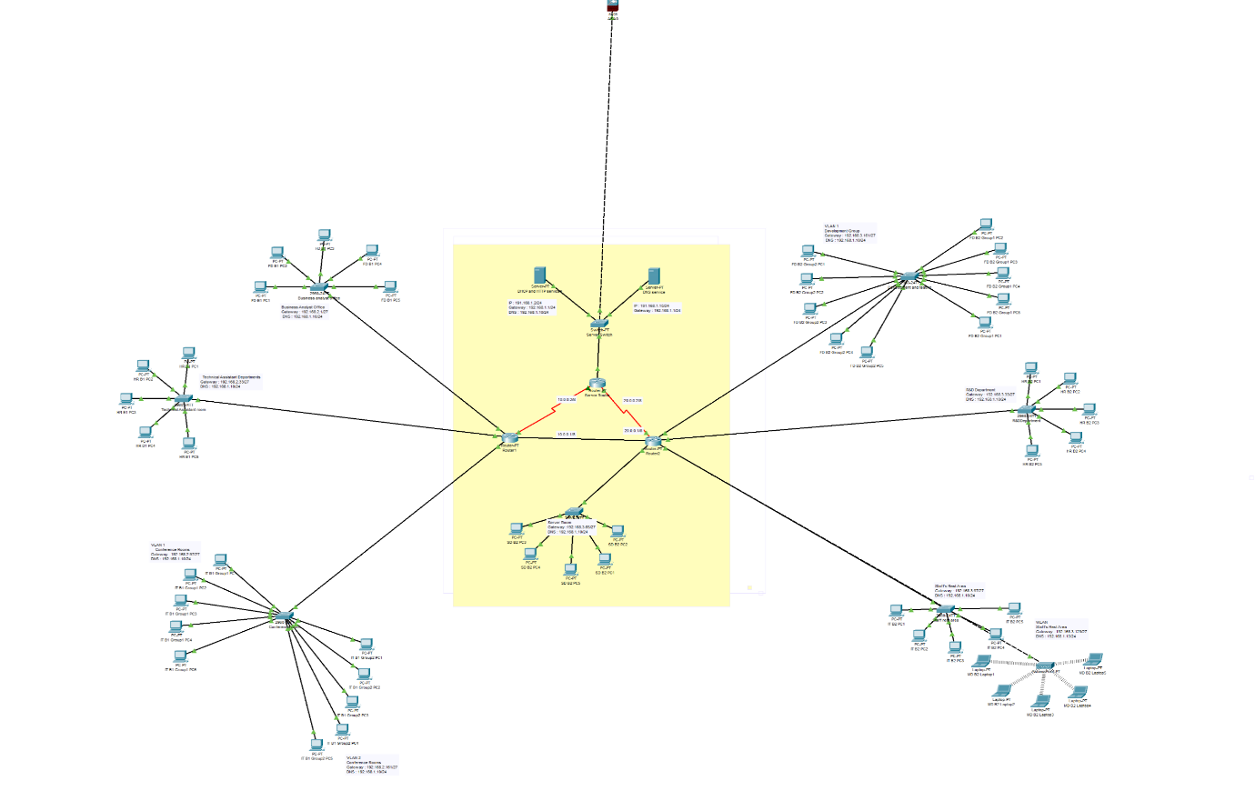

|  |  |  |  |
| --- | --- | --- | --- |
| Room Name | Gateway | DNS | IP Range |
| R&D Department | 192.168.2.1/21 | 192.168.1.10/24 | 192.168.2.1 to 192.168.7.254 |
| Development and Testing  VLAN 1 | 192.168.3.33/27 | 192.168.1.10/24 | 192.168.3.33 to 192.168.3.62 |
| Development and Testing  VLAN 2 | 192.168.3.1 /27 | 192.168.1.10/24 | 192.168.3.1 to 192.168.3.30 |
| Business Analyst Office | 192.168.2.1/21 | 192.168.1.10/24 | 192.168.2.1 to 192.168.7.254 |
| Technical Assistant Departments | 192.168.2.33/27 | 192.168.1.10/24 | 192.168.2.33 to 192.168.2.62 |
| Conference Room VLAN 1 | 192.168.1.10/24 | 192.168.1.10/24 | 192.168.1.1 to 192.168.1.254 |
| Conference Room VLAN 2 | 192.168.1.10/24 | 192.168.1.10/24 | 192.168.1.1 to 192.168.1.254 |
| Staff Rest Area 1 | 192.168.3.97/27 | 192.168.1.10/24 | 192.168.3.97 to 192.168.3.126 |
| Staff Rest Area 2: | 192.168.3.129/27 | 192.168.1.10/24 | 192.168.3.129 to 192.168.3.158 |
| Server | 192.168.3.65/27 | 192.168.1.10/24 | 192.168.3.65 to 192.168.3.94 |

# Configuration and Demonstration

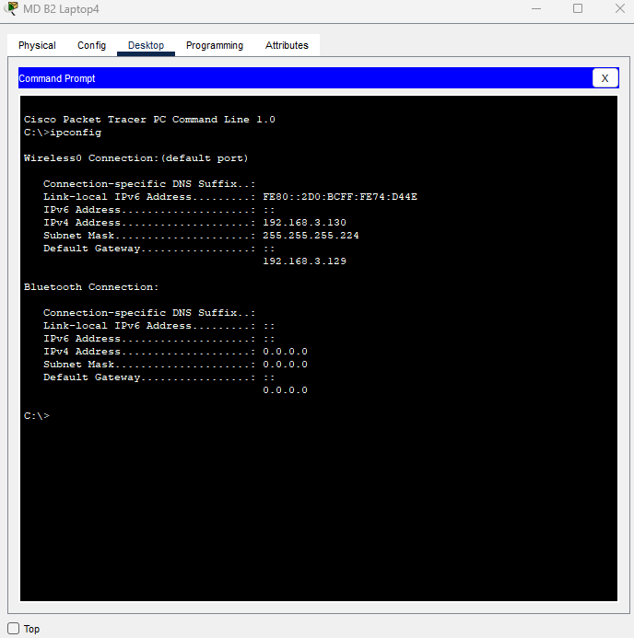

**Self-Reflection:** This group project allowed me to learn about how IP works, how to work effectively in a group, how to make a floor plan, which was important for developing a networking concept, and how each IP communicates with one another via IP configuration.